11.14: a) Taking torques about the pivot, and using the 3-4-5 geometry,

so 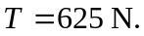 b) The horizontal force must balance the horizontal component of the force exerted by the rope, or 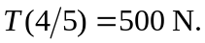 The vertical force is 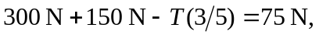 upwards.

